**Name:** Adeel Mustafa

**ID:** BIT-23F-028

**Class:** BSIT-3A

**Section:** A

**Lab Title:**  Artificial Intelligence

**Instructor:**  Aqsa Umar

**Objectives 01: Make 2 Programs on each data type.**

**01. Numeric Types:**

**-Int**

# Python Integer  
a = 25  
y = -78  
c = 0  
  
print(a)   
print(y)    
print(c)

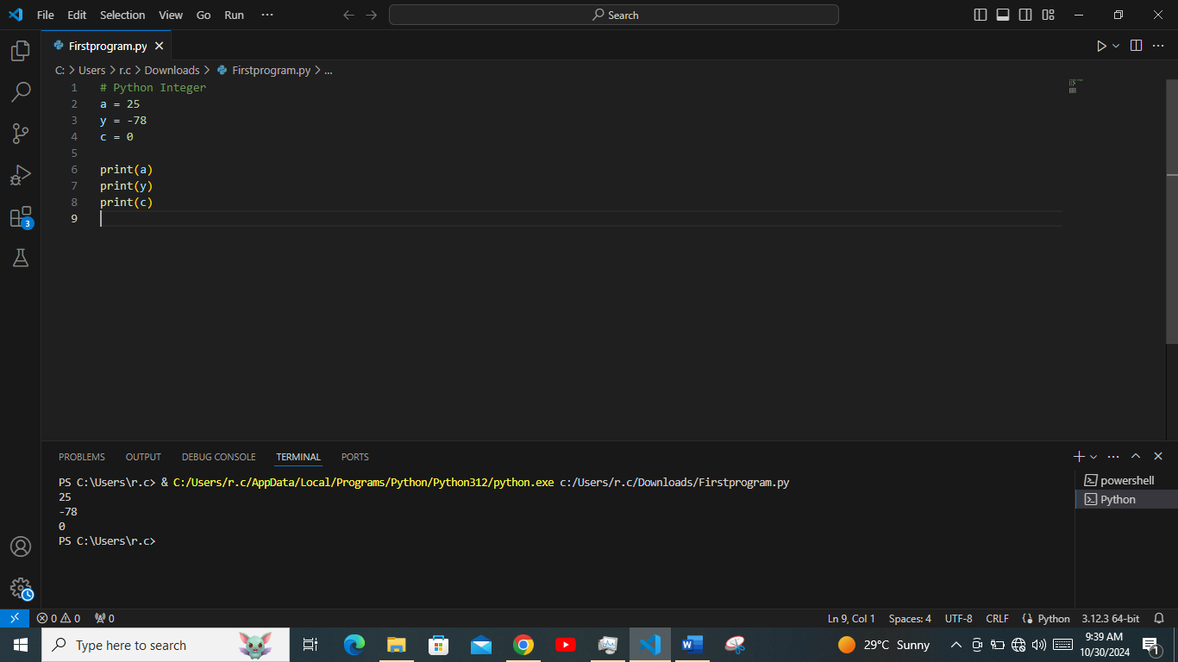

*# Addition Operation +*

addition = 8 + 3

print("Addition:", addition)

*# Subtraction operation -*

subtraction = 9 - 4

print("Subtraction:", subtraction)

*# Multiplication operation \**

multiplication = 10 * 2

print("Multiplication:", multiplication)

*# Division operation /*

division = 10 / 6

print("Division:", division)

*# Integer Division operation //*

integer_division = 10 // 2

print("Integer Division:", integer_division)

*# Modulus operation %*

modulus = 10 % 5

print("Modulus:", modulus)

*# Exponentiation operation \*\**

exponentiation = 2 ** 6

print("Exponentiation:", exponentiation)

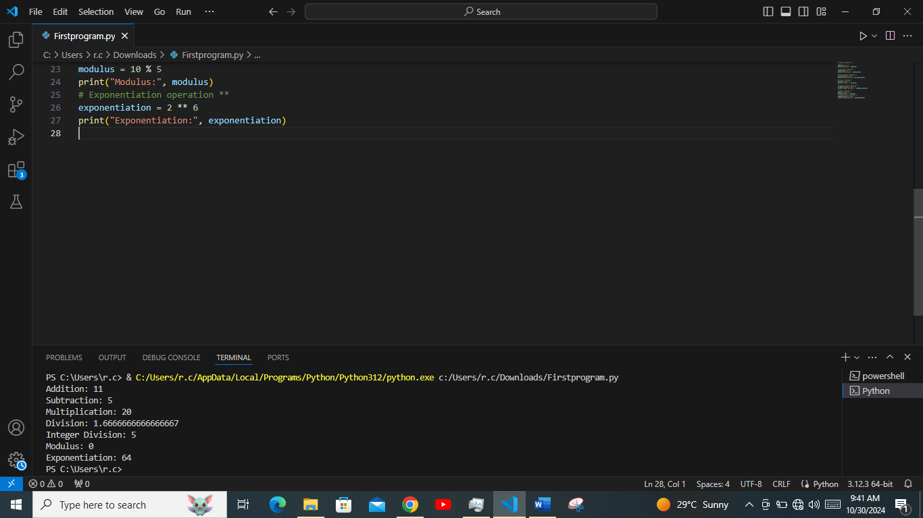

-**Flaot**

b = 2.47

y = -0.1

k = 5.0

print(b)

print(y)

print(k)

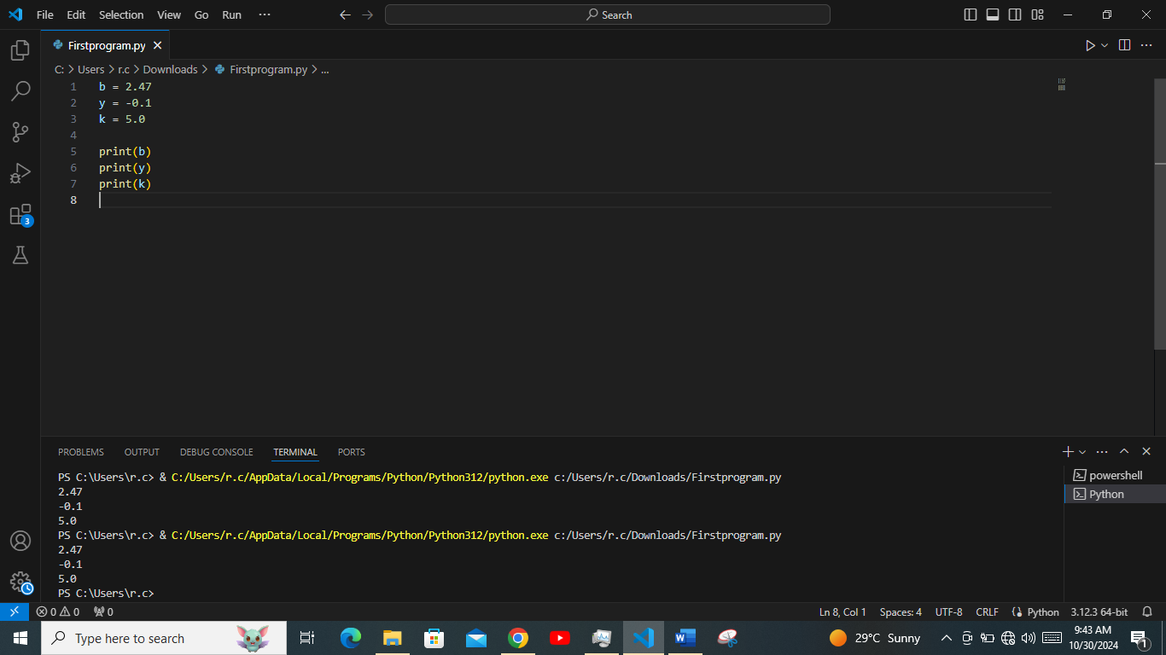

**Sequence Type:**

*# List creation*

the_list = [1, 2, 4, 5]

*# creating a mixed data list*

multiple_data_list = [1, 'hi', 2.57, False]

print(the_list[0])

print(multiple_data_list[2])

*# Mutable feature of list*

the_list[0] = 10

the_list.append(9)

the_list.extend([5, 4])

the_list.remove(2)

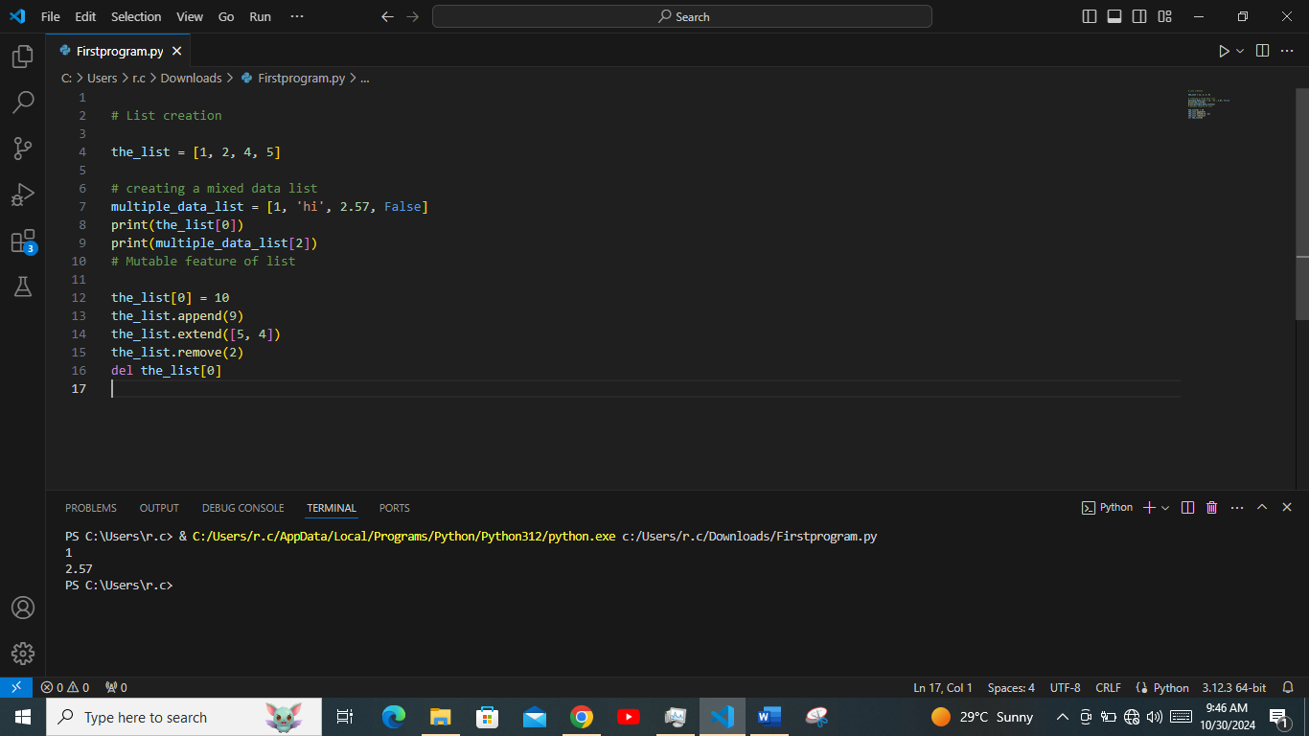del the_list[0]